**SUPPLEMENTARY MATERIAL**

**Supplement Table 1.** Distribution of forest management unit sizes (in ha): minimum, median, mean, and maximum values.

|  |  |  |  |  |
| --- | --- | --- | --- | --- |
| Forest Management Unit | Minimum | Median | Mean | Maximum |
| Forest regional directorates | 6906.9 | 18458.8 | 27624.8 | 82445.2 |
| Forest district directorates | 164.4 | 1712.2 | 3144.3 | 29632.4 |
| Forest sub-district directorates | 0.02 | 234.9 | 554.9 | 18908.5 |

**Supplement Table 2.** Percentage of the number of fire incidents and burned area in six selected regions and the whole Türkiye (rows) based on various fire size classes (columns). A short version of this table is presented in Table 1.

|  |  |  |  |  |  |  |  |  |
| --- | --- | --- | --- | --- | --- | --- | --- | --- |
|  |  |  | **Fire size (ha)** | | | | | |
| **Region** | **Origin** |  | **0-100** | **100-101** | **101-102** | **102-103** | **103-104** | **104-105** |
| **Türkiye** | **Human** | occurrence (%) | 39.17 | 8.96 | 1.57 | 0.28 | 0.04 | 0.01 |
| area (%) | 1.62 | 4.44 | 6.95 | 13.41 | 25.55 | 16.05 |
| **Lightning** | occurrence (%) | 11.50 | 0.74 | 0.07 | 0.01 | - | - |
| area (%) | 0.26 | 0.35 | 0.30 | 0.61 | - | - |
| **Unknown** | occurrence (%) | 29.27 | 7.13 | 1.05 | 0.18 | 0.02 | 0 |
| area (%) | 1.24 | 3.61 | 4.68 | 7.61 | 9.87 | 3.45 |
| **Total** | occurrence (%) | 79.93 | 16.82 | 2.69 | 0.48 | 0.07 | 0.01 |
| area (%) | 3.12 | 8.4 | 11.93 | 21.63 | 35.42 | 19.5 |
| **Muğla** | **Human** | occurrence (%) | 35.85 | 4.41 | 1.11 | 0.22 | 0.05 | 0.02 |
| area (%) | 0.78 | 1.28 | 2.84 | 5.32 | 17.49 | 17.85 |
| **Lightning** | occurrence (%) | 29.12 | 0.76 | 0.06 | 0.03 | - | - |
| area (%) | 0.33 | 0.2 | 0.19 | 0.33 | - | - |
| **Unknown** | occurrence (%) | 24.11 | 3.22 | 0.65 | 0.3 | 0.08 | 0.02 |
| area (%) | 0.45 | 0.97 | 2.05 | 7.11 | 27.79 | 15.02 |
| **Total** | occurrence (%) | 89.08 | 8.39 | 1.82 | 0.55 | 0.13 | 0.03 |
| area (%) | 1.55 | 2.45 | 5.08 | 12.76 | 45.28 | 32.87 |
| **Bolu** | **Human** | occurrence (%) | 27.63 | 9.7 | 1.35 | 0.13 | - | - |
| area (%) | 3.88 | 9.84 | 20.33 | 13.7 | - | - |
| **Lightning** | occurrence (%) | 21.16 | 2.96 | 0.4 | - | - | - |
| area (%) | 1.63 | 3.61 | 3.27 | - | - | - |
| **Unknown** | occurrence (%) | 27.49 | 8.49 | 0.27 | 0.4 | - | - |
| area (%) | 3.56 | 9.46 | 3.44 | 27.27 | - | - |
| **Total** | occurrence (%) | 76.28 | 21.16 | 2.02 | 0.54 | - | - |
| area (%) | 9.08 | 22.91 | 27.03 | 40.98 | - | - |
| **İstanbul** | **Human** | occurrence (%) | 42.37 | 4.07 | 0.37 | - | - | - |
| area (%) | 9.61 | 20.18 | 14.4 | - | - | - |
| **Lightning** | occurrence (%) | 0.97 | 0.03 | - | - | - | - |
| area (%) | 0.28 | 0.17 | - | - | - | - |
| **Unknown** | occurrence (%) | 48.51 | 3.37 | 0.23 | 0.07 | - | - |
| area (%) | 12.68 | 15.26 | 13.33 | 14.11 | - | - |
| **Total** | occurrence (%) | 91.85 | 7.48 | 0.6 | 0.07 | - | - |
| area (%) | 22.57 | 35.6 | 27.73 | 14.11 | - | - |
| **İzmir** | **Human** | occurrence (%) | 74.91 | 13.78 | 2.55 | 0.58 | 0.06 | - |
| area (%) | 3.62 | 8.41 | 15.65 | 42.74 | 28.08 | - |
| **Lightning** | occurrence (%) | 5.7 | 0.52 | 0.02 | - | - | - |
| area (%) | 0.12 | 0.28 | 0.06 | - | - | - |
| **Unknown** | occurrence (%) | 1.48 | 0.33 | 0.04 | 0.02 | - | - |
| area (%) | 0.08 | 0.15 | 0.25 | 0.55 | - | - |
| **Total** | occurrence (%) | 82.09 | 14.63 | 2.61 | 0.61 | 0.06 | - |
| area (%) | 3.82 | 8.84 | 15.97 | 43.29 | 28.08 | - |
| **Erzurum** | **Human** | occurrence (%) | 20.12 | 15.92 | 4.2 | - | - | - |
| area (%) | 1.84 | 12.33 | 17.19 | - | - | - |
| **Lightning** | occurrence (%) | 0.9 | 1.2 | - | - | - | - |
| area (%) | 0.03 | 0.79 | - | - | - | - |
| **Unknown** | occurrence (%) | 27.93 | 23.72 | 5.41 | 0.6 | - | - |
| area (%) | 3.05 | 14.44 | 30.25 | 20.08 | - | - |
| **Total** | occurrence (%) | 48.95 | 40.84 | 9.61 | 0.6 | - | - |
| area (%) | 4.92 | 27.55 | 47.44 | 20.08 | - | - |
| **Elazığ** | **Human** | occurrence (%) | 11.56 | 8.84 | 2.21 | 0.09 | - | - |
| area (%) | 0.94 | 5.95 | 10.05 | 5.8 | - | - |
| **Lightning** | occurrence (%) | 2.81 | 0.43 | 0.09 | - | - | - |
| area (%) | 0.21 | 0.45 | 0.24 | - | - | - |
| **Unknown** | occurrence (%) | 43.54 | 26.11 | 4.08 | 0.26 | - | - |
| area (%) | 3.7 | 18.35 | 22.94 | 31.37 | - | - |
| **Total** | occurrence (%) | 57.91 | 35.37 | 6.38 | 0.34 | - | - |
| area (%) | 4.85 | 24.75 | 33.22 | 37.18 | - | - |

**Supplement Table 3.** Number and percentage of wildfires of different origin by regional units.

|  |  |  |  |  |  |  |  |  |
| --- | --- | --- | --- | --- | --- | --- | --- | --- |
| Regional unit | Number of Fires | | | |  | Percentage of Fires | | |
| Total | Human | Lightning | Unknown |  | Human (%) | Lightning (%) | Unknown (%) |
| Adana | 2452 | 1222 | 268 | 962 |  | 49.8 | 10.9 | 39.2 |
| Amasya | 1864 | 616 | 97 | 1151 |  | 33.0 | 5.2 | 61.7 |
| Ankara | 1483 | 490 | 133 | 860 |  | 33.0 | 9.0 | 58.0 |
| Antalya | 4421 | 2284 | 532 | 1605 |  | 51.7 | 12.0 | 36.3 |
| Artvin | 166 | 93 | 19 | 54 |  | 56.0 | 11.4 | 32.5 |
| Balıkesir | 1409 | 826 | 134 | 449 |  | 58.6 | 9.5 | 31.9 |
| Bolu | 742 | 288 | 182 | 272 |  | 38.8 | 24.5 | 36.7 |
| Bursa | 1479 | 641 | 201 | 637 |  | 43.3 | 13.6 | 43.1 |
| Çanakkale | 880 | 637 | 121 | 122 |  | 72.4 | 13.8 | 13.9 |
| Denizli | 1602 | 781 | 256 | 565 |  | 48.8 | 16.0 | 35.3 |
| Elazığ | 1176 | 267 | 39 | 870 |  | 22.7 | 3.3 | 74.0 |
| Erzurum | 333 | 134 | 7 | 192 |  | 40.2 | 2.1 | 57.7 |
| Eskişehir | 701 | 254 | 102 | 345 |  | 36.2 | 14.6 | 49.2 |
| Giresun | 668 | 393 | 4 | 271 |  | 58.8 | 0.6 | 40.6 |
| Isparta | 1214 | 412 | 317 | 485 |  | 33.9 | 26.1 | 40.0 |
| İstanbul | 2995 | 1402 | 30 | 1563 |  | 46.8 | 1.0 | 52.2 |
| İzmir | 4790 | 4401 | 299 | 90 |  | 91.9 | 6.2 | 1.9 |
| Kahramanmaraş | 2778 | 1274 | 172 | 1332 |  | 45.9 | 6.2 | 47.9 |
| Kastamonu | 1578 | 476 | 202 | 900 |  | 30.2 | 12.8 | 57.0 |
| Kayseri | 398 | 141 | 13 | 244 |  | 35.4 | 3.3 | 61.3 |
| Konya | 682 | 341 | 34 | 307 |  | 50.0 | 5.0 | 45.0 |
| Kütahya | 1040 | 440 | 234 | 366 |  | 42.3 | 22.5 | 35.2 |
| Mersin | 1709 | 1256 | 233 | 220 |  | 73.5 | 13.6 | 12.9 |
| Muğla | 6329 | 2636 | 1897 | 1796 |  | 41.6 | 30.0 | 28.4 |
| Sakarya | 1225 | 675 | 24 | 526 |  | 55.1 | 2.0 | 42.9 |
| Şanlıurfa | 1199 | 337 | 19 | 843 |  | 28.1 | 1.6 | 70.3 |
| Sinop | 158 | 55 | 22 | 81 |  | 34.8 | 13.9 | 51.3 |
| Trabzon | 510 | 335 | 7 | 168 |  | 65.7 | 1.4 | 32.9 |
| Zonguldak | 1283 | 543 | 222 | 518 |  | 42.3 | 17.3 | 40.4 |

**Supplement Table 4.** The top-10 list of forest sub-districts (local units) with the highest percentage of lightning-induced fires. The regional units they belong to, the percentages of lightning-induced, human-caused, and unknown-origin fires, and the total number of wildfires between 2002 and 2022 in each local unit are given. Only local units with a minimum of 10 fires were considered.

|  |  |  |  |  |  |
| --- | --- | --- | --- | --- | --- |
| **Local unit** | **Regional unit** | **Wildfire origin** | | | **Total number of wildfires** |
| **Lightning (%)** | **Human (%)** | **Unknown (%)** |
| Karacaören | Denizli | 93 | 0 | 7 | 14 |
| Çiçekli | Denizli | 89 | 4 | 7 | 28 |
| Ağla | Muğla | 86 | 7 | 7 | 44 |
| Cebel | Isparta | 82 | 9 | 9 | 11 |
| Sultaniye | Muğla | 82 | 9 | 9 | 68 |
| Çakmak | Muğla | 81 | 10 | 10 | 42 |
| Namnam | Muğla | 81 | 13 | 6 | 52 |
| Yılanlı | Muğla | 81 | 6 | 13 | 31 |
| Eskere | Denizli | 76 | 12 | 12 | 17 |
| Çaldere | Muğla | 75 | 10 | 15 | 114 |

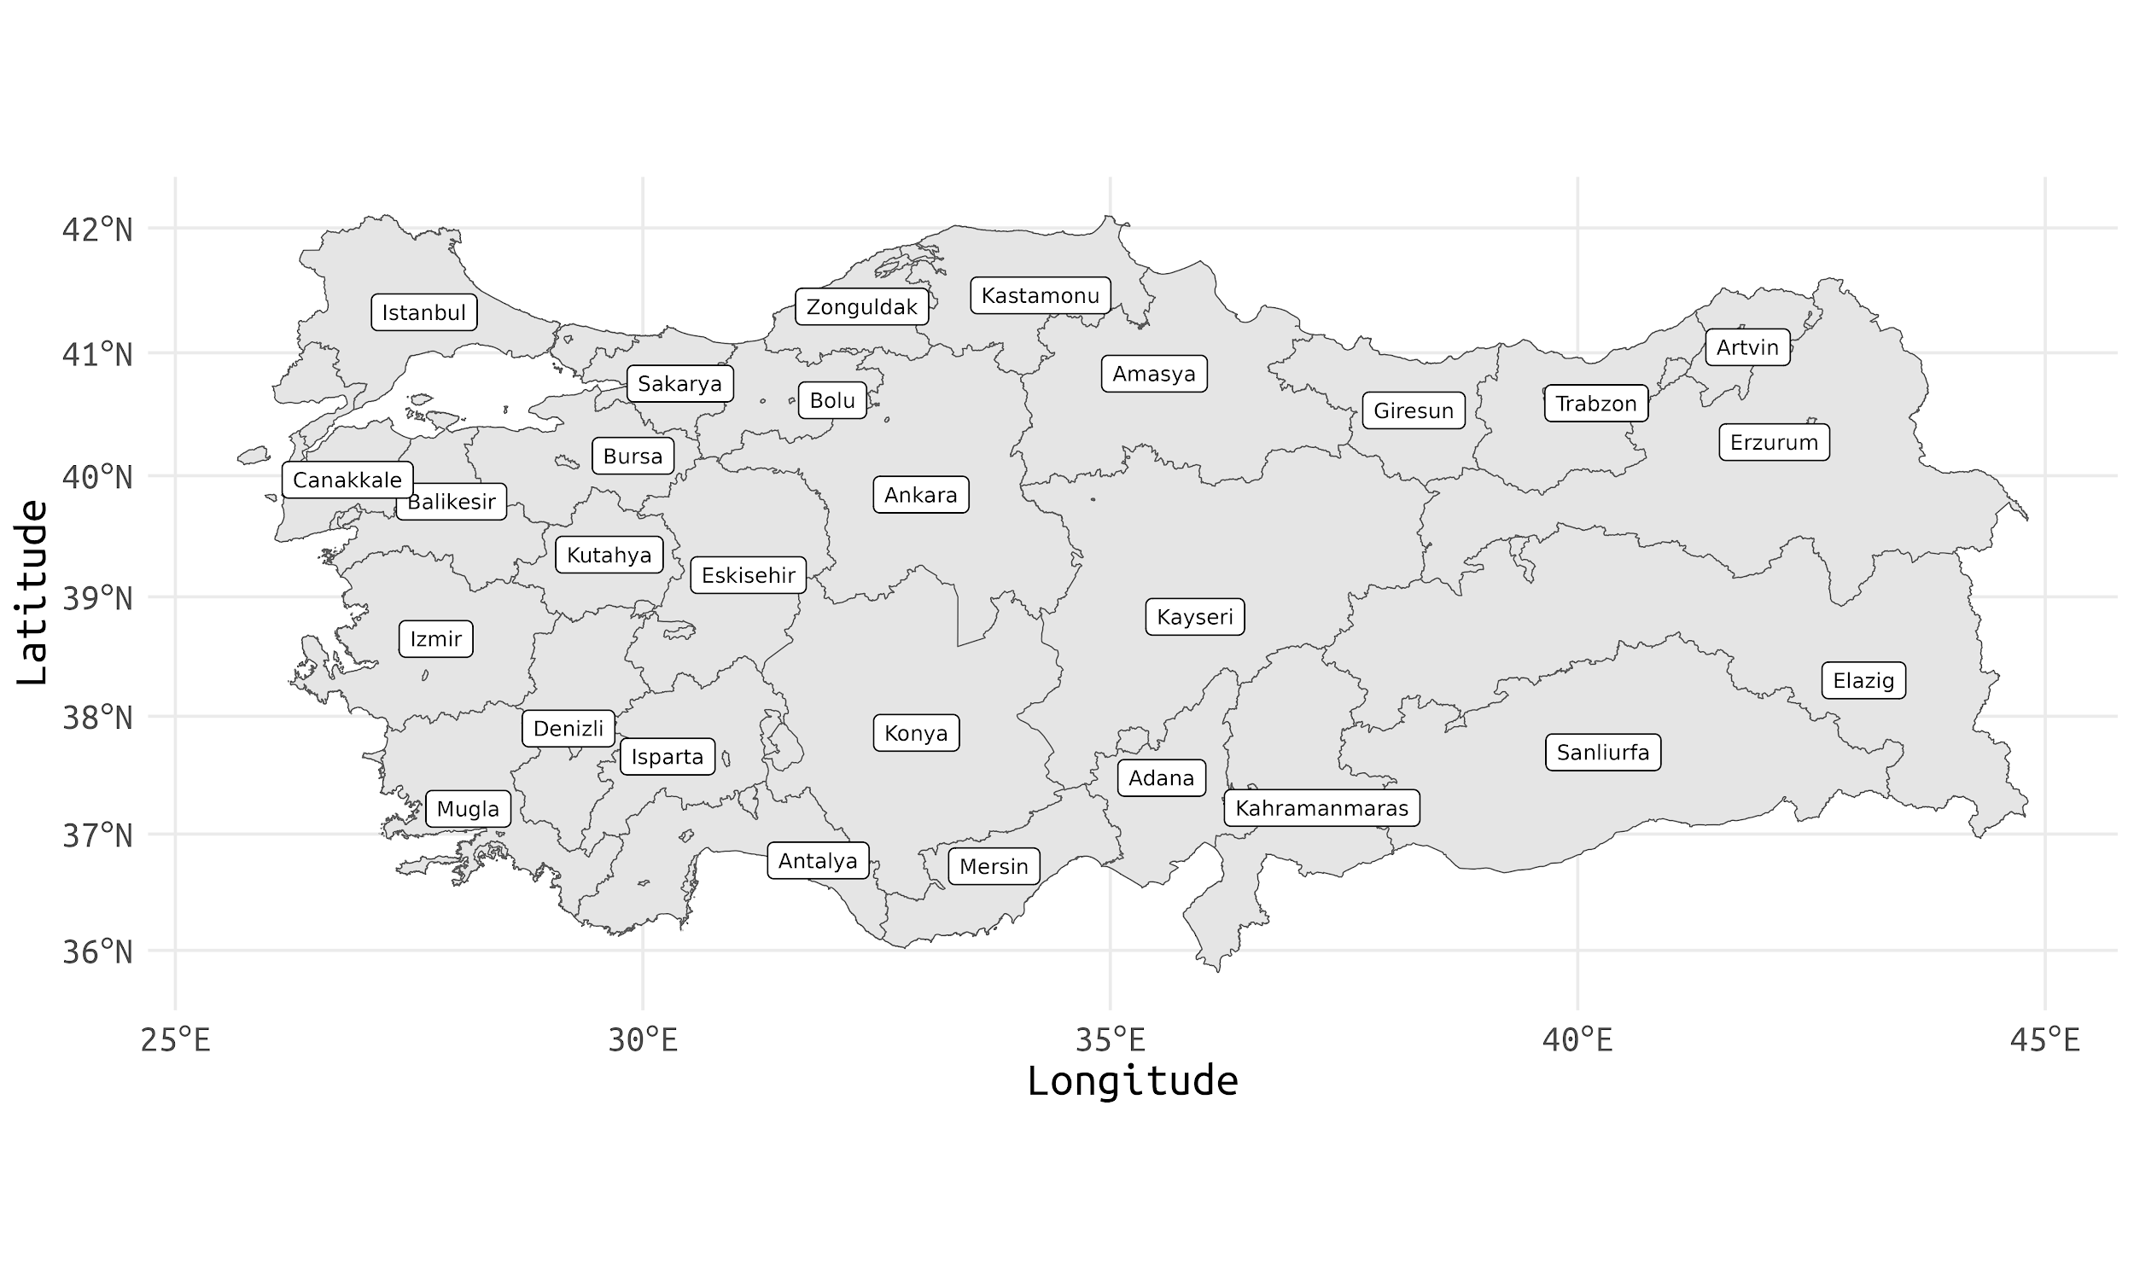

**a**

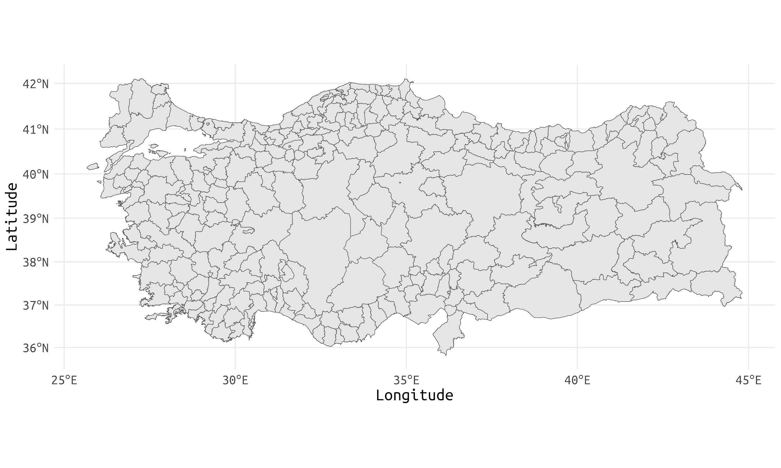

**b**

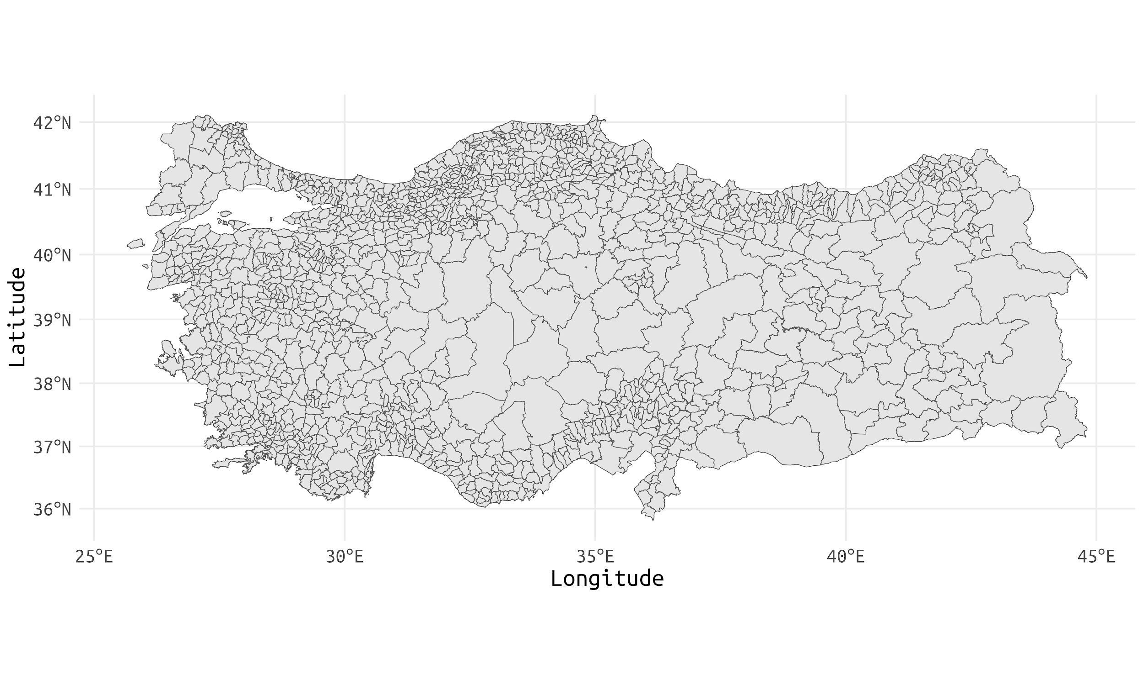

**c**

**Supplement Figure 1.** Administrative boundaries of forest regional directorates (a), forest district directorates (b), and forest sub-district directorates (c).