Supplementary Material to the paper Tüfekcioğlu, İ., Tavşanoğlu, Ç. Diversity and regeneration strategies in woody plant communities of the Mediterranean Basin: Vegetation type matters. Plant Biosystems.

Supplementary Table 1. Vegetation type classes used in the study and their corresponding classes in forest management plans. Vegetation type classes were described according to the General Directorate of Forestry (2017).

Vegetation type classes
In the study | In forest management plans | Description
Semi-closed forest | Turkish red pine forest | Mainly consists of mature Turkish red pine individuals with total coverage between 11% and 40%.
Open forest | Open Turkish red pine forest | Mainly consists of mature Turkish red pine individuals with total coverage < 10%.
Closed shrubland | Maquis | Mainly consists of large shrubs with total coverage between 11% and 100%.
Open shrubland | Open maquis | Mainly consists of large shrubs with total coverage < 10%.
Scrubland | Forest soil without any tree | Mainly consists of species that do not exceed 1 m height.

References
The General Directorate of Forestry. 2017. Notification for ecosystem based functional forest management plans. No: 299, Ankara. (in Turkish).

Supplementary Table 2. The species recorded in the study and their taxonomic and some ecological properties. Regeneration strategy of a species (sensu Pausas 1999 and Pausas et al., 2004) includes information on both resprouting ability after the fire (resprouters: R+ or non-resprouters: R-), post-fire persistence ability via any propagule (propagule-persister: P+ or propagule-non-persister: P-), and the seed bank locality in propagule-persisters (canopy seed bank: c or soil seed bank: s). Growth form, resprouting ability, post-fire persistence via propagules, and seed bank locality information are based on the BROT database (Tavşanoğlu & Pausas, 2018) and field observations. Nomenclature follows Davis (1965-1985), but taxon and family names were updated according to The Plant List (2013).

Species | Family | Growth form | Resprouting ability | Regeneration strategy
Arbutus andrachne L. | Ericaceae | large shrub | yes | R+P-
Arbutus unedo L. | Ericaceae | large shrub | yes | R+P-
Asparagus aphyllus L. | Asparagaceae | liana | yes | R+P-
Asperula brevifolia Vent. | Rubiaceae | subshrub | no | unknown
Calicotome villosa (Poir.) Link | Leguminosae | shrub | yes | R+P+
Celtis australis L. | Cannabaceae | tree | yes | R+P-
Ceratonia siliqua L. | Leguminosae | tree | yes | R+P-
Cistus creticus L. | Cistaceae | shrub | no | R-P+s
Cistus parviflorus Lam. | Cistaceae | shrub | no | R-P+s
Cistus salviifolius L. | Cistaceae | shrub | no | R-P+s
Cotinus coggygria Scop. | Anacardiaceae | large shrub | yes | R+P-
Crataegus monogyna Jacq. | Rosaceae | large shrub | yes | R+P-
Cupressus sempervirens L. | Cupressaceae | tree | no | R-P+c
Cytisopsis pseudocytisus (Boiss.) Fertig | Leguminosae | subshrub | no | R-P+s
Daphne gnidioides Jaub. & Spach | Thymelaeaceae | shrub | unknown | unknown
Daphne sericea Vahl | Thymelaeaceae | shrub | variable | unknown
Dittrichia viscosa (L.) Greuter | Compositae | subshrub | yes | R+P+
Erica manipuliflora Salisb. | Ericaceae | shrub | yes | R+P+
Euphorbia acanthothamnos Heldr. & Sart. ex Boiss. | Euphorbiaceae | subshrub | yes | R+P+
Genista acanthoclada DC. | Leguminosae | shrub | yes | R+P+
Hypericum empetrifolium Willd. | Hypericaceae | subshrub | unknown | R+P+
Juniperus oxycedrus L. | Cupressaceae | large shrub | yes | R+P-
Laurus nobilis L. | Lauraceae | large shrub | yes | R+P-
Lavandula stoechas L. | Lamiaceae | subshrub | no | R-P+s
Myrtus communis L. | Myrtaceae | large shrub | yes | R+P-
Olea europaea L. | Oleaceae | tree | yes | R+P-
Origanum onites L. | Lamiaceae | subshrub | yes | R+P-
Osyris alba L. | Santalaceae | large shrub | yes | R+P-
Paliurus spina-christi Mill. | Rhamnaceae | large shrub | yes | R+P-
Phillyrea latifolia L. | Oleaceae | large shrub | yes | R+P-
Phlomis grandiflora H. S. Thomps. | Lamiaceae | shrub | unknown | unknown
Phlomis lycia D. Don | Lamiaceae | shrub | yes | unknown
Pinus brutia Ten. | Pinaceae | tree | no | R-P+c
Pistacia lentiscus L. | Anacardiaceae | large shrub | yes | R+P-
Pistacia terebinthus L. | Anacardiaceae | large shrub | yes | R+P-
Populus nigra L. | Salicaceae | tree | yes | R+P-
Ptilostemon chamaepeuce (L.) Less. | Compositae | shrub | yes | unknown
Pyrus elaeagnifolia Pall. | Rosaceae | tree | unknown | unknown
Quercus aucheri Jaub. & Spach | Fagaceae | large shrub | yes | R+P-
Quercus coccifera L. | Fagaceae | large shrub | yes | R+P-
Quercus infectoria subsp. veneris (A.Kern.) Meikle | Fagaceae | large shrub | yes | R+P-
Quercus ithaburensis Decne. | Fagaceae | tree | yes | R+P-
Rhamnus punctata Boiss. | Rhamnaceae | large shrub | unknown | unknown
Rhamnus pyrella O. Schwarz | Rhamnaceae | shrub | yes | R+P-
Rubia tenuifolia d´Urv. | Rubiaceae | liana | yes | R+P-
Ruscus aculeatus L. | Asparagaceae | subshrub | yes | R+P-
Sarcopoterium spinosum (L.) Spach | Rosaceae | subshrub | yes | R+P+
Satureja thymbra L. | Lamiaceae | subshrub | variable | unknown
Smilax aspera L. | Smilacaceae | liana | yes | R+P-
Spartium junceum L. | Leguminosae | large shrub | yes | R+P+
Styrax officinalis L. | Styracaceae | large shrub | yes | R+P-
Teucrium chamaedrys subsp. syspirense (C. Koch) Rech. f. | Lamiaceae | subshrub | yes | R+P-
Teucrium divaricatum Sieber ex Heldr. | Lamiaceae | subshrub | yes | R+P+
Teucrium polium L. | Lamiaceae | subshrub | yes | R+P+
Teucrium sandrasicum O. Schwarz | Lamiaceae | subshrub | unknown | unknown
Thymbra capitata (L.) Cav. | Lamiaceae | subshrub | variable | unknown

References
Davis, P.H. (ed.) 1965–1985. Flora of Turkey and the East Aegean Islands, Volumes 1–9, Edinburgh: Edinburg University Press.
Pausas, J.G. 1999. Response of plant functional types to changes in the fire regime in Mediterranean ecosystems: a simulation approach. Journal of Vegetation Science 10: 717–722.
Pausas, J.G., Bradstock, R.A., Keith, D.A., Keeley, J.E., Fire Network GCTE. 2004 Plant functional traits in relation to fire in crown-fire ecosystems. Ecology 85: 1085–1100.
Tavşanoğlu, Ç., Pausas, J.G. 2018. A functional trait database for Mediterranean Basin plants. Scientific Data 5: 180135.
The Plant List 2013. The Plant List, version 1.1. http://www.theplantlist.org/ [accessed on 08.12.2020].

Supplementary Table 3. Mean species richness and Shannon diversity values for each vegetation type estimated from the transect data. Model results for differences in species richness (Poisson GLM) and Shannon diversity (linear model) among different vegetation types. The same letters next to the values indicate no significant difference (P > 0.05) across vegetation types.

 | Semi-closed forest | Open forest | Closed shrubland | Open shrubland | Scrubland | Poisson GLM
 |  |  |  |  |  | Dev. | P
Species richness
Mature individuals | 9.6a | 9.4a | 15.3b | 13.5b | 7.3a | 53.6 | < 0.0001
Saplings | 9.2a | 9.5a | 11.4a | 10.0a | 5.0b | 34.9 | < 0.0001
Shannon diversity |  |  |  |  |  | Linear model
 |  |  |  |  |  | F | P
Mature individuals | 1.7ab | 1.6b | 2.3c | 1.9ac | 1.2d | 23.1 | < 0.0001
Saplings | 1.7a | 1.7a | 1.9a | 1.9a | 1.4b | 6.5 | 0.0001

Supplementary Table 4. The frequency of occurrence of each species in the belt transects in each vegetation type. Values are the percentage of transects in which mature individuals of the species were recorded.

Species | Vegetation type
 | Semi-closed forest | Open forest | Closed shrubland | Open shrubland | Scrubland
Arbutus andrachne | 11.11 | 83.33 | 4.17 | 17.65 | 0
Arbutus unedo | 11.11 | 41.67 | 0 | 0 | 0
Asparagus aphyllus | 50.00 | 83.33 | 66.67 | 70.59 | 25.00
Asperula brevifolia | 0 | 8.33 | 0 | 23.53 | 0
Calicotome villosa | 5.56 | 33.33 | 20.83 | 35.29 | 33.33
Celtis australis | 0 | 0 | 4.17 | 0 | 0
Ceratonia siliqua | 5.56 | 8.33 | 4.17 | 11.76 | 0
Cistus creticus | 72.22 | 91.67 | 54.17 | 70.59 | 50.00
Cistus parviflorus | 0 | 0 | 4.17 | 35.29 | 0
Cistus salviifolius | 72.22 | 75.00 | 54.17 | 52.94 | 50.00
Cotinus coggygria | 11.11 | 0 | 4.17 | 0 | 0
Crataegus monogyna | 5.56 | 0 | 0 | 35.29 | 25.00
Cupressus sempervirens | 0 | 8.33 | 0 | 0 | 0
Cytisopsis pseudocytisus | 16.67 | 0 | 16.67 | 0 | 0
Daphne gnidioides | 22.22 | 0 | 16.67 | 52.94 | 25.00
Daphne sericea | 5.56 | 8.33 | 0 | 0 | 0
Dittrichia viscosa | 0 | 0 | 0 | 5.88 | 0
Erica manipuliflora | 27.78 | 0 | 58.33 | 17.65 | 0
Euphorbia acanthothamnos | 0 | 41.67 | 0 | 29.41 | 8.33
Genista acanthoclada | 44.44 | 75.00 | 79.17 | 70.59 | 58.33
Hypericum empetrifolium | 5.56 | 100.00 | 12.50 | 29.41 | 0
Juniperus oxycedrus | 0 | 0 | 4.17 | 0 | 0
Laurus nobilis | 11.11 | 8.33 | 0 | 5.88 | 0
Lavandula stoechas | 38.89 | 0 | 54.17 | 41.18 | 50.00
Myrtus communis | 5.56 | 0 | 12.50 | 5.88 | 0
Olea europaea | 38.89 | 91.67 | 25.00 | 70.59 | 33.33
Origanum onites | 0 | 8.33 | 4.17 | 29.41 | 16.67
Osyris alba | 0 | 41.67 | 4.17 | 41.18 | 0
Paliurus spina-christi | 5.56 | 0 | 12.50 | 0 | 0
Phillyrea latifolia | 61.11 | 100.00 | 70.83 | 52.94 | 25.00
Phlomis grandiflora | 0 | 25.00 | 0 | 35.29 | 0
Phlomis lycia | 22.22 | 25.00 | 4.17 | 52.94 | 33.33
Pinus brutia | 100.00 | 50.00 | 95.83 | 11.76 | 0
Pistacia lentiscus | 27.78 | 100.00 | 25.00 | 76.47 | 33.33
Pistacia terebinthus | 16.67 | 41.67 | 12.50 | 5.88 | 0
Populus nigra | 5.56 | 0 | 0 | 0 | 0
Ptilostemon chamaepeuce | 0 | 33.33 | 12.50 | 5.88 | 16.67
Pyrus elaeagnifolia | 11.11 | 0 | 0 | 29.41 | 33.33
Quercus aucheri | 16.67 | 66.67 | 0 | 47.06 | 25.00
Quercus coccifera | 61.11 | 91.67 | 29.17 | 82.35 | 33.33
Quercus infectoria subsp. veneris | 44.44 | 8.33 | 16.67 | 11.76 | 0
Quercus ithaburensis | 0 | 0 | 0 | 0 | 8.33
Rhamnus punctata | 0 | 0 | 20.83 | 0 | 25.00
Rubia tenuifolia | 0 | 16.67 | 0 | 0 | 0
Ruscus aculeatus | 16.67 | 83.33 | 16.67 | 0 | 0
Sarcopoterium spinosum | 50.00 | 16.67 | 33.33 | 70.59 | 100.00
Satureja thymbra | 0 | 0 | 16.67 | 11.76 | 0
Smilax aspera | 22.22 | 41.67 | 41.67 | 11.76 | 0
Spartium junceum | 0 | 8.33 | 0 | 0 | 0
Styrax officinalis | 27.78 | 0 | 4.17 | 17.65 | 0
Teucrium chamaedrys subsp. syspirense | 0 | 0 | 0 | 5.88 | 0
Teucrium polium | 0 | 0 | 4.17 | 17.65 | 0
Teucrium sandrasicum | 0 | 0 | 4.17 | 0 | 0
Thymbra capitata | 5.56 | 8.33 | 12.50 | 52.94 | 16.67

Supplementary Table 5. The density of each species in each vegetation type. Values are the mean (±SD) number of mature individuals per transect in each vegetation type. The results of generalized linear models (GLM) based on (1) the number of individuals of each species without zero data in each transect (GLM assuming Poisson distribution) and (2) the presence and absence of species in each transect (GLM assuming binomial distribution) are given. Dev. is the deviance value obtained from GLM analyses, and deviance values lower than 0.05 were stated as 0.0.

Species | Vegetation type |  |  |  |  | Poisson GLM |  | Binomial GLM
 | Semi-closed forest | Open forest | Closed shrubland | Open shrubland | Scrubland | Dev. | P | Dev. | P
Arbutus andrachne | 0.17±0.5 | 0.08±0.4 | 9.42±8.9 | 2.24±6.7 | 0 | 35.6 | < 0.0001 | 33.8 | < 0.0001
Arbutus unedo | 0.11±0.3 | 0 | 1.42±2.6 | 0 | 0 | 3.7 | 0.0556 | 19.2 | 0.0007
Asparagus aphyllus | 3.28±5.4 | 5.25±7.9 | 12.33±11.3 | 3.82±5.8 | 2.25±6.3 | 58.8 | < 0.0001 | 11.1 | 0.0250
Asperula brevifolia | 0 | 0 | 0.33±1.2 | 0.88±1.7 | 0 | 0.0 | 0.9093 | 12.4 | 0.0149
Calicotome villosa | 0.06±0.2 | 1.58±4.8 | 2.42±4.6 | 2.06±5.2 | 0.42±0.7 | 30.5 | < 0.0001 | 6.7 | 0.1498
Celtis australis | 0 | 0.21±1.0 | 0 | 0 | 0 | - | - | 2.5 | 0.6425
Ceratonia siliqua | 0.11±0.5 | 0.13±0.6 | 0.33±1.2 | 0.24±0.7 | 0 | 1.2 | 0.7635 | 2.5 | 0.6358
Cistus creticus | 22.17±32.2 | 22.67±36.9 | 29.25±21.5 | 12.35±18.5 | 29.25±55.5 | 231.6 | < 0.0001 | 7.6 | 0.1063
Cistus parviflorus | 0 | 0.54±2.7 | 0 | 14.59±30.5 | 0 | 23.7 | < 0.0001 | 17.6 | 0.0015
Cistus salviifolius | 51.72±55.5 | 34.33±58.9 | 39.42±60.0 | 61.65±92.2 | 3.75±6.7 | 822.1 | < 0.0001 | 3.5 | 0.4716
Cotinus coggygria | 1.44±4.7 | 0.04±0.2 | 0 | 0 | 0 | 14.7 | 0.0001 | 4.9 | 0.2935
Crataegus monogyna | 0.06±0.2 | 0 | 0 | 0.53±1.0 | 0.33±0.7 | 0.2 | 0.9146 | 17.8 | 0.0014
Cupressus sempervirens | 0 | 0 | 0.50±1.7 | 0 | 0 | - | - | 3.9 | 0.4140
Cytisopsis pseudocytisus | 0.94±2.6 | 1.54±4.9 | 0 | 0 | 0 | 2.9 | 0.0861 | 10.2 | 0.0377
Daphne gnidioides | 0.33±0.7 | 0.50±1.7 | 0 | 6.53±10.1 | 1.00±2.1 | 71.5 | < 0.0001 | 14.0 | 0.0074
Daphne sericea | 0.06±0.2 | 0 | 0.33±1.2 | 0 | 0 | 1.9 | 0.1650 | 4.2 | 0.3737
Dittrichia viscosa | 0 | 0 | 0 | 0.06±0.2 | 0 | - | - | 3.2 | 0.5218
Erica manipuliflora | 20.50±38.2 | 37.25±55.8 | 0 | 4.94±12.9 | 0 | 81.6 | < 0.0001 | 26.3 | < 0.0001
Euphorbia acanthothamnos | 0 | 0 | 0.83±1.2 | 2.24±4.4 | 0.08±0.3 | 21.6 | < 0.0001 | 21.2 | 0.0003
Genista acanthoclada | 11.50±19.5 | 36.17±46.5 | 12.83±11.1 | 39.82±42.2 | 37.75±57.4 | 361.1 | < 0.0001 | 6.4 | 0.1693
Hypericum empetrifolium | 0.11±0.5 | 4.13±15.3 | 41.42±30.1 | 14.24±29.3 | 0 | 76.8 | < 0.0001 | 47.5 | < 0.0001
Juniperus oxycedrus | 0 | 0.04±0.2 | 0 | 0 | 0 | - | - | 2.5 | 0.6425
Laurus nobilis | 0.17±0.5 | 0 | 0.08±0.3 | 0.06±0.2 | 0 | 0.2 | 0.9042 | 5.0 | 0.2857
Lavandula stoechas | 9.72±18.8 | 5.21±6.9 | 0 | 1.53±2.2 | 2.42±3.9 | 165.4 | < 0.0001 | 14.7 | 0.0053
Myrtus communis | 0.72±3.1 | 0.17±0.5 | 0 | 0.29±1.2 | 0 | 19.9 | < 0.0001 | 4.4 | 0.3581
Olea europaea | 1.11±2.2 | 0.54±1.2 | 9.42±7.6 | 4.18±5.4 | 1.58±3.1 | 62.4 | < 0.0001 | 21.1 | 0.0003
Origanum onites | 0 | 0.21±1.0 | 0.08±0.3 | 3.00±7.1 | 3.17±7.9 | 29.0 | < 0.0001 | 10.4 | 0.0347
Osyris alba | 0 | 0.79±3.9 | 2.58±3.6 | 4.65±11.1 | 0 | 15.9 | 0.0004 | 24.4 | < 0.0001
Paliurus spina-christi | 0.22±0.9 | 1.13±3.2 | 0 | 0 | 0 | 2.8 | 0.0952 | 6.3 | 0.1809
Phillyrea latifolia | 10.00±15.9 | 10.17±10.2 | 33.17±13.5 | 3.82±4.9 | 1.58±3.5 | 242.3 | < 0.0001 | 19.7 | 0.0006
Phlomis grandiflora | 0 | 0 | 1.17±2.5 | 3.71±9.3 | 0 | 8.8 | 0.0030 | 21.4 | 0.0003
Phlomis lycia | 2.94±7.0 | 0.46±2.2 | 0.33±0.7 | 13.00±22.6 | 4.92±10.8 | 107.2 | < 0.0001 | 14.2 | 0.0066
Pinus brutia | 12.17±4.7 | 8.92±7.2 | 2.08±2.8 | 0.12±0.3 | 0 | 60.2 | < 0.0001 | 75.1 | < 0.0001
Pistacia lentiscus | 2.22±4.1 | 1.17±2.8 | 7.58±6 | 5.06±5.4 | 0.50±0.8 | 29.2 | < 0.0001 | 32.9 | < 0.0001
Pistacia terebinthus | 0.61±1.8 | 0.50±1.5 | 0.58±0.8 | 0.06±0.2 | 0 | 7.7 | 0.0521 | 10.4 | 0.0345
Populus nigra | 0.06±0.2 | 0 | 0 | 0 | 0 | - | - | 3.1 | 0.5410
Ptilostemon chamaepeuce | 0 | 0.25±0.7 | 1.25±3.4 | 0.06±0.2 | 0.75±1.8 | 4.9 | 0.1795 | 9.3 | 0.0543
Pyrus elaeagnifolia | 0.50±1.5 | 0 | 0 | 0.82±1.6 | 2.58±4.9 | 11.0 | 0.0040 | 16.5 | 0.0024
Quercus aucheri | 1.11±3.6 | 0 | 1.83±1.9 | 4.24±7.1 | 0.67±1.3 | 34.6 | < 0.0001 | 27.5 | < 0.0001
Quercus coccifera | 5.39±6.5 | 4.17±10.4 | 12.42±14.6 | 13.35±14.4 | 2.08±4.1 | 45.2 | < 0.0001 | 22.6 | 0.0002
Quercus infectoria subsp. veneris | 2.39±4.3 | 1.71±4.2 | 1.08±3.8 | 0.18±0.5 | 0 | 25.2 | < 0.0001 | 12.9 | 0.0119
Quercus ithaburensis | 0 | 0 | 0 | 0 | 0.08±0.3 | - | - | 3.9 | 0.4140
Rhamnus punctata | 0 | 0.29±0.7 | 0 | 0 | 0.58±1.1 | 0.9 | 0.3418 | 14.6 | 0.0057
Rubia tenuifolia | 0 | 0 | 0.25±0.6 | 0 | 0 | - | - | 8.0 | 0.0901
Ruscus aculeatus | 0.28±0.7 | 0.46±1.6 | 4.08±5.1 | 0 | 0 | 8.8 | 0.0126 | 35.5 | < 0.0001
Sarcopoterium spinosum | 7.50±12.6 | 3.75±10.3 | 2.08±4.9 | 52.18±90.6 | 146.25±97.5 | 2083.0 | < 0.0001 | 28.0 | < 0.0001
Satureja thymbra | 0 | 2.33±9.6 | 0 | 0.35±1.2 | 0 | 19.2 | < 0.0001 | 9.1 | 0.0577
Smilax aspera | 1.06±2.1 | 1.29±2.8 | 8.50±11.3 | 0.12±0.3 | 0 | 130.9 | < 0.0001 | 13.6 | 0.0087
Spartium junceum | 0 | 0 | 0.08±0.3 | 0 | 0 | - | - | 3.9 | 0.4140
Styrax officinalis | 3.94±9.6 | 0.08±0.4 | 0 | 0.65±1.8 | 0 | 32.9 | < 0.0001 | 11.5 | 0.0211
Teucrium chamaedrys subsp. syspirense | 0 | 0 | 0 | 0.06±0.2 | 0 | - | - | 3.2 | 0.5218
Teucrium polium | 0 | 0.46±2.2 | 0 | 0.35±0.8 | 0 | 11.9 | 0.0006 | 7.9 | 0.0951
Teucrium sandrasicum | 0 | 0.08±0.4 | 0 | 0 | 0 | - | - | 2.5 | 0.6425
Thymbra capitata | 0.11±0.5 | 6.38±17.7 | 0.08±0.3 | 39.59±46.2 | 11.50±35.9 | 249.4 | < 0.0001 | 14.4 | 0.0062

Supplementary Table 6. The coverage of each species in each vegetation type. Values are the mean (±SD) cover of mature individuals per transect in each vegetation type. The results of linear models testing the difference of cover values among vegetation types are given for each species. In some cases, statistical analysis could not be performed due to the lack of a species in several vegetation types. Cover values lower than 0.005 were stated as “0.00”, while the “0” value means that the species did not present in the corresponding vegetation type.

Species | Vegetation type |  |  |  |  | Linear model
 | Semi-closed forest | Open forest | Closed shrubland | Open shrubland | Scrubland | F | P
Arbutus andrachne | 0.04±0.1 | 0.02±0.1 | 15.41±15.9 | 3.96±12.0 | 0 | 1.1 | 0.3831
Arbutus unedo | 0.20±0.8 | 0 | 3.01±7.0 | 0 | 0 | 0.5 | 0.4938
Asparagus aphyllus | 0.15±0.3 | 0.31±0.5 | 0.66±0.6 | 0.22±0.4 | 0.04±0.1 | 2.0 | 0.1123
Asperula brevifolia | 0 | 0 | 0.05±0.2 | 0.09±0.2 | 0 | 0.7 | 0.4602
Calicotome villosa | 0.00±0.0 | 1.30±4.4 | 0.88±1.5 | 0.81±2.4 | 0.14±0.3 | 1.0 | 0.4612
Celtis australis | 0 | 0.01±0.1 | 0 | 0 | 0 | - | -
Ceratonia siliqua | 0.17±0.7 | 0.10±0.5 | 0.60±2.1 | 0.38±1.1 | 0 | 3.7 | 0.3613
Cistus creticus | 3.19±6.0 | 6.59±15.0 | 7.83±7.0 | 1.71±2.9 | 4.55±8.7 | 1.5 | 0.2073
Cistus parviflorus | 0 | 0.03±0.1 | 0 | 2.00±4.5 | 0 | 0.6 | 0.4856
Cistus salviifolius | 14.91±18.9 | 4.82±9.4 | 7.25±11.4 | 11.00±15.6 | 0.50±0.8 | 3.0 | 0.0293
Cotinus coggygria | 0.81±2.4 | 0.03±0.2 | 0 | 0 | 0 | 19.6 | 0.1413
Crataegus monogyna | 0.01±0.0 | 0 | 0 | 1.01±3.7 | 0.39±1.0 | 0.1 | 0.8688
Cupressus sempervirens | 0 | 0 | 0.66±2.3 | 0 | 0 | - | -
Cytisopsis pseudocytisus | 0.07±0.2 | 0.22±0.8 | 0 | 0 | 0 | 0.8 | 0.4153
Daphne gnidioides | 0.08±0.2 | 0.05±0.2 | 0 | 1.09±1.9 | 0.26±0.7 | 1.4 | 0.2779
Daphne sericea | 0.01±0.0 | 0 | 0.57±2.0 | 0 | 0 | - | -
Dittrichia viscosa | 0 | 0 | 0 | 0.00±0.0 | 0 | - | -
Erica manipuliflora | 11.41±20.3 | 24.12±38.6 | 0 | 3.55±8.5 | 0 | 0.4 | 0.6542
Euphorbia acanthothamnos | 0 | 0 | 0.14±0.2 | 0.16±0.3 | 0.00±0.0 | 1.3 | 0.3217
Genista acanthoclada | 2.94±5.1 | 9.36±13.1 | 2.84±2.6 | 9.72±9.9 | 10.58±17.8 | 1.9 | 0.1252
Hypericum empetrifolium | 0.00±0.0 | 0.32±1.0 | 3.63±2.9 | 0.87±1.8 | 0 | 0.6 | 0.6112
Juniperus oxycedrus | 0 | 0.00±0.0 | 0 | 0 | 0 | - | -
Laurus nobilis | 0.17±0.7 | 0 | 0.01±0.0 | 0.05±0.2 | 0 | 0.2 | 0.8579
Lavandula stoechas | 0.79±1.5 | 0.38±0.6 | 0 | 0.11±0.2 | 0.26±0.3 | 4.5 | 0.0106
Myrtus communis | 0.66±2.8 | 0.37±1.2 | 0 | 0.50±2.0 | 0 | 7.2 | 0.1213
Olea europaea | 0.68±1.5 | 0.52±1.7 | 18.34±21.0 | 2.94±4.3 | 1.36±2.4 | 4.2 | 0.0071
Origanum onites | 0 | 0.02±0.1 | 0.01±0.0 | 0.28±0.7 | 0.52±1.2 | 3.3 | 0.1153
Osyris alba | 0 | 0.02±0.1 | 0.23±0.4 | 0.10±0.2 | 0 | 1.4 | 0.2899
Paliurus spina-christi | 0.51±2.2 | 1.52±4.3 | 0 | 0 | 0 | 0.4 | 0.5919
Phillyrea latifolia | 12.22±21.3 | 7.13±7.3 | 29.65±16.0 | 4.80±7.4 | 0.69±1.6 | 4.6 | 0.0032
Phlomis grandiflora | 0 | 0 | 0.24±0.5 | 0.33±1.0 | 0 | 0.0 | 0.9634
Phlomis lycia | 0.34±0.8 | 0.06±0.3 | 0.17±0.5 | 1.44±2.3 | 1.06±2.3 | 0.7 | 0.6048
Pinus brutia | 96.09±30.4 | 61.61±42.7 | 18.1±23.0 | 0.26±1.0 | 0 | 7.8 | 0.0003
Pistacia lentiscus | 5.63±10.3 | 2.42±6.1 | 8.90±11.4 | 8.64±8.9 | 3.22±5.7 | 1.4 | 0.2637
Pistacia terebinthus | 0.34±0.9 | 0.52±1.5 | 0.43±0.6 | 0.07±0.3 | 0 | 5.3 | 0.0260
Populus nigra | 0.12±0.5 | 0 | 0 | 0 | 0 | - | -
Ptilostemon chamaepeuce | 0 | 0.02±0.1 | 0.28±0.8 | 0.02±0.1 | 0.18±0.4 | 0.5 | 0.6951
Pyrus elaeagnifolia | 0.34±1.1 | 0 | 0 | 1.91±4.6 | 1.37±2.5 | 0.4 | 0.6865
Quercus aucheri | 4.01±15.3 | 0 | 4.82±5.7 | 2.53±5.0 | 0.23±0.4 | 1.9 | 0.1603
Quercus coccifera | 11.34±18.6 | 2.83±6.7 | 13.56±16.2 | 13.53±12.6 | 2.01±4.0 | 0.7 | 0.5647
Quercus infectoria subsp. veneris | 2.83±4.2 | 1.67±4.5 | 0.21±0.7 | 0.82±2.3 | 0 | 0.9 | 0.4659
Quercus ithaburensis | 0 | 0 | 0 | 0 | 0.1±0.4 | - | -
Rhamnus punctata | 0 | 0.07±0.2 | 0 | 0 | 0.29±0.6 | 6.4 | 0.0452
Rubia tenuifolia | 0 | 0 | 0.02±0.0 | 0 | 0 | - | -
Sarcopoterium spinosum | 1.25±2.6 | 0.38±0.8 | 0.22±0.6 | 6.84±12.7 | 40.28±24.6 | 12.0 | < 0.0001
Satureja thymbra | 0 | 0.37±1.7 | 0 | 0.05±0.2 | 0 | 0.4 | 0.5687
Spartium junceum | 0 | 0 | 0.02±0.1 | 0 | 0 | - | -
Styrax officinalis | 4.06±10.8 | 0.07±0.4 | 0 | 0.50±1.5 | 0 | 0.8 | 0.4957
Teucrium chamaedrys subsp. syspirense | 0 | 0 | 0 | 0.00±0.0 | 0 | - | -
Teucrium polium | 0 | 0.01±0.1 | 0 | 0.03±0.1 | 0 | 0.4 | 0.5887
Teucrium sandrasicum | 0 | 0.01±0.1 | 0 | 0 | 0 | - | -
Thymbra capitata | 0.01±0.0 | 0.99±2.8 | 0.01±0.0 | 6.80±8.5 | 1.45±4.3 | 1.4 | 0.2921

Supplementary Table 7. The density (ind./transect) and cover (%) of different growth forms for each vegetation type. Values are the mean (±SD) of transects.

Density of mature individuals | Semi-closed forest | Open forest | Closed shrubland | Open shrubland | Scrubland
subshrub | 17.0±26.8 | 27.0±28.9 | 48.9±33.7 | 114.5±96.3 | 163.4±123.7
shrub | 108.9±66.1 | 137.6±91.4 | 87.0±55.1 | 158.7±93.0 | 77.8±71.8
lar. shrub | 27.6±22.8 | 20.1±15.7 | 70.2±31.6 | 35.1±19.8 | 5.8±9.2
tree | 13.1±5.1 | 10.0±7.4 | 12.3±8.5 | 5.4±5.0 | 4.2±5.5
liana | 3.9±6.4 | 7.3±9.6 | 21.1±18.5 | 3.9±5.9 | 2.2±6.3
Density of saplings
subshrub | 30.9±48.3 | 56.0±79.3 | 29.1±18.2 | 57.5±50.4 | 38.8±26.8
shrub | 83.5±58.4 | 141.7±114.1 | 45.3±35.0 | 129.4±149.5 | 40.6±44.3
lar. shrub | 85.9±78.2 | 49.5±62.5 | 105.6±83.7 | 49.0±40.4 | 3.5±6.7
tree | 10.9±13.3 | 15.6±24.0 | 2.4±3.8 | 0.8±1.3 | 1.6±1.4
liana | 74.6±150.7 | 35.4±115.3 | 21.4±18.1 | 4.3±6.4 | 0.8±2.3
Cover of mature individuals
subshrub | 2.0±3.5 | 3.0±3.6 | 5.2±3.9 | 15.2±13.6 | 42.5±26.1
shrub | 34.0±22.7 | 47.2±34.1 | 20.1±10.2 | 31.7±20.6 | 17.3±19.1
lar. shrub | 39.4±39.6 | 16.4±13.1 | 76.3±34.7 | 36.5±23.6 | 6.8±6.8
tree | 91.5±31.3 | 63.1±45.4 | 37.7±33.8 | 5.5±5.3 | 2.8±3.1

Supplementary Table 8. The density (ind./transect) and cover (%) of different regeneration strategies for each vegetation type. Values are the mean (±SD) of transects.

Density of mature individuals | Semi-closed forest | Open forest | Closed shrubland | Open shrubland | Scrubland
R-P+c | 11.6±4.8 | 9.1±7.6 | 2.6±3.0 | 0.1±0.3 | 0
R-P+s | 78.3±69.5 | 67.7±79.6 | 68.7±48.3 | 90.1±91.1 | 35.4±60.3
R+P- | 32.8±25.6 | 33.7±32.9 | 146.6±36.9 | 60.8±37.7 | 12.6±14.6
R+P+ | 44.3±41.2 | 80.1±72.3 | 18.3±14.0 | 101.7±89.0 | 184.5±69.0
Density of saplings
R-P+c | 10.1±12.9 | 15.0±23.7 | 1.7±2.7 | 0 | 0.2±0.4
R-P+s | 77.3±63.9 | 97.5±101.9 | 36.3±36.0 | 93.4±140.7 | 29.3±47.1
R+P- | 161.2±218.0 | 88.9±148.9 | 156.3±93.3 | 65.6±59.0 | 4.6±6.4
R+P+ | 30.5±32.8 | 67.1±78.5 | 3.9±3.9 | 42.4±32.2 | 45.5±21.1
Cover of mature individuals
R-P+c | 90.4±31.4 | 62.4±45.7 | 18.8±22.6 | 0.2±1.0 | 0
R-P+s | 17.3±19.1 | 12.7±17.9 | 15.1±8.8 | 14.8±15.3 | 5.3±9.4
R+P- | 40.3±39.6 | 17.8±13.3 | 100.7±31.1 | 41.2±25.1 | 8.6±7.2
R+P+ | 18.2±19.9 | 35.4±38.0 | 4.1±2.5 | 21.1±15.0 | 51.0±11.0

Supplementary Table 9. The mean density (ind./transect) and cover (%) of different resprouting ability groups (yes: resprouter, no: non-resprouter) for each vegetation type. Generalized linear models assuming Poisson distribution and general linear models assuming Gaussian distribution were used to analyze the density (i.e., the number of saplings and mature individuals) and cover, respectively. Dev. is deviance. The same letters next to the values indicate no significant difference (P > 0.05) across vegetation types.

Resprouting ability | Semi-closed forest | Open forest |  |  | Scrubland | Poisson GLM
 |  |  | Closed shrubland | Open shrubland |  | Dev. | P
Density of mature individuals
Yes | 79.6a | 114.6b | 166.4c | 175.5c | 202.4d | 1241.0 | <0.0001
No | 89.9a | 76.7b | 71.6b | 91.1a | 35.4c | 426.3 | <0.0001
Density of saplings
Yes | 194.7a | 161.8b | 160.5b | 115.6c | 52.2d | 1435.7 | <0.0001
No | 87.5a | 112.6b | 37.9c | 93.6a | 29.5d | 1135.2 | <0.0001
 |  |  |  |  |  | Linear Model
 |  |  |  |  |  | F | P
Cover of mature individuals
Yes | 58.8a | 53.3a | 105.2b | 63.8a | 60.8a | 7.0 | <0.0001
No | 107.7a | 75.0b | 33.9c | 15.2c | 5.3c | 31.7 | <0.0001

Supplementary Table 10. The results of pairwise PERMANOVA analyses comparing vegetation types. Statistical significance was considered as P < 0.01 due to several pairwise comparisons.

Vegetation types | Number data |  |  | Cover data |  |  | Presence data
 | R² | P |  | R² | P |  | R² | P
Semi-closed forest vs. Closed shrubland | 0.188 | 0.001 |  | 0.383 | 0.001 |  | 0.289 | 0.001
Semi-closed forest vs. Open forest | 0.052 | 0.041 |  | 0.097 | 0.004 |  | 0.200 | 0.001
Semi-closed forest vs. Open shrubland | 0.139 | 0.001 |  | 0.374 | 0.001 |  | 0.319 | 0.001
Semi-closed forest vs. Scrubland | 0.268 | 0.001 |  | 0.528 | 0.001 |  | 0.397 | 0.001
Closed shrubland vs. Open forest | 0.169 | 0.001 |  | 0.263 | 0.001 |  | 0.360 | 0.001
Closed shrubland vs. Open shrubland | 0.210 | 0.001 |  | 0.207 | 0.001 |  | 0.333 | 0.001
Closed shrubland vs. Scrubland | 0.416 | 0.001 |  | 0.437 | 0.001 |  | 0.594 | 0.001
Open forest vs. Open shrubland | 0.118 | 0.001 |  | 0.263 | 0.001 |  | 0.272 | 0.001
Open forest vs. Scrubland | 0.220 | 0.001 |  | 0.374 | 0.001 |  | 0.321 | 0.001
Open shrubland vs. Scrubland | 0.157 | 0.002 |  | 0.209 | 0.001 |  | 0.197 | 0.001

Supplementary Figure 1. Rarefaction curves for Shannon diversity of mature individuals (A) and saplings (B) in the sampled transects.

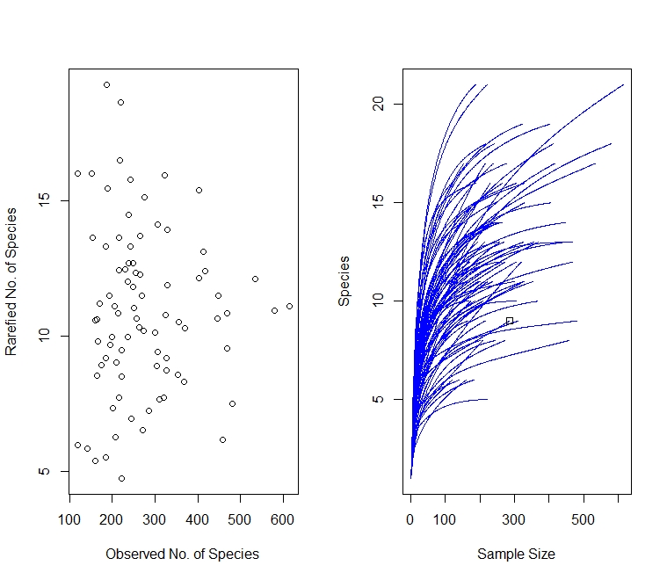
A
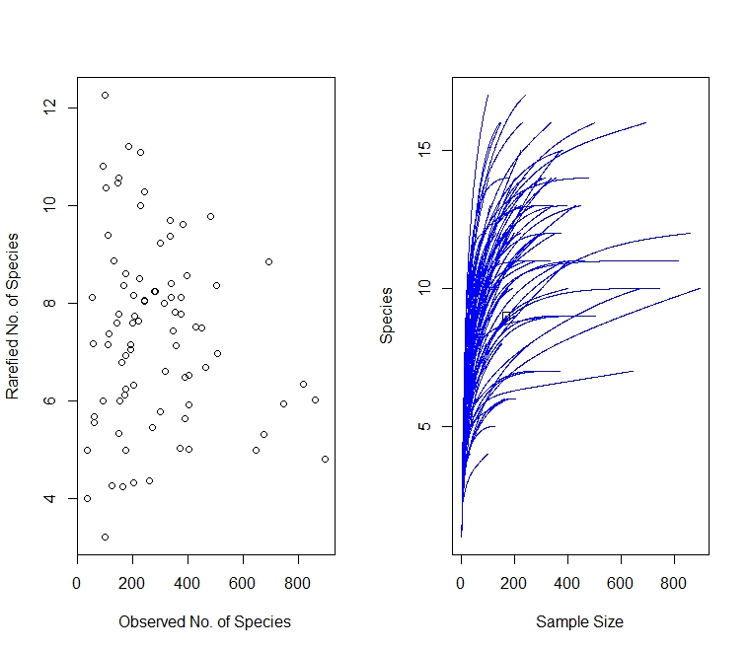
B

Supplementary Figure 2. Relative total number of mature individuals (A) and saplings (B), and relative total cover mature individuals (C) for two resprouting ability classes (yes: resprouter, no: non-resprouter) in each vegetation type.

A 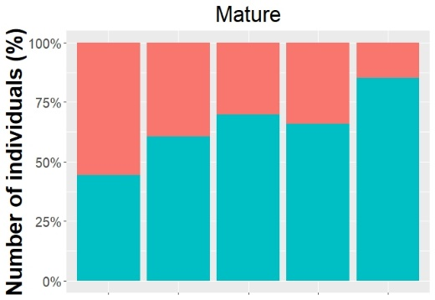
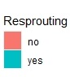
B 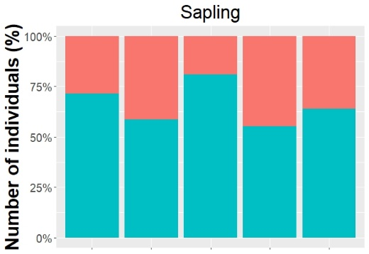
C 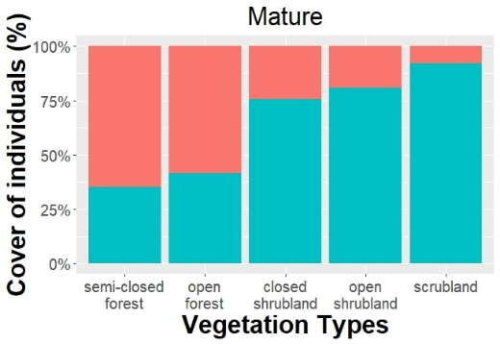

Supplementary Figure 3. Shepard plot for NMDS analyses of the number (a), cover (b), and presence (c) of mature individuals.

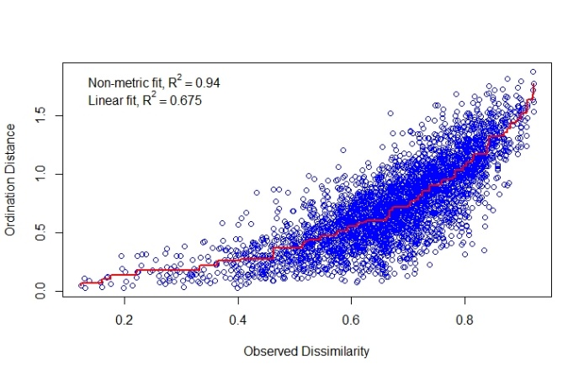
a

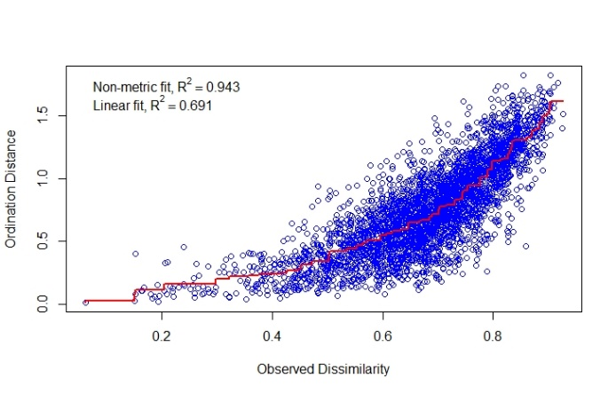
b

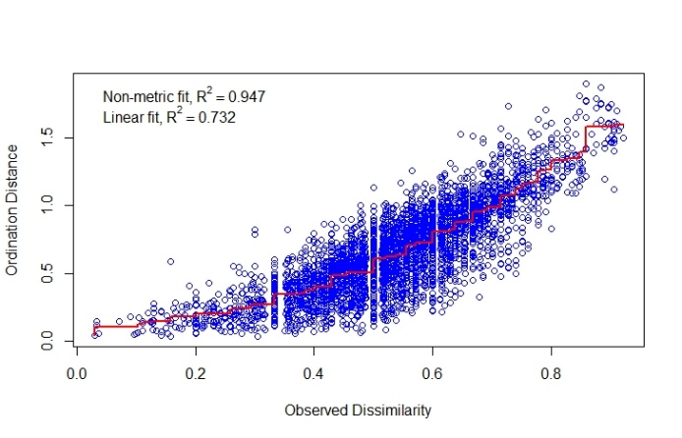
c

