SUPPORTING INFORMATION

Contrasting responses in germination and early seedling survival and growth to warming in Trojan fir

Table S1. Monthly mean (T_{mean}), minimum (T_{min}), and maximum (T_{max}) temperatures and monthly total precipitation at the seed collection site. Annual means of temperature variables and annual total precipitation are also provided. Data are from WorldClim v.2.1 (Fick and Hijmans 2017).
 | Temperature
Month | T_{mean} (°C) | T_{min} (°C) | T_{max} (°C) | Precipitation (mm)
January | 0.4 | -2.4 | 3.1 | 112
February | 0.4 | -2.4 | 3.3 | 100
March | 2.5 | -1.0 | 5.9 | 82
April | 6.8 | 2.9 | 10.7 | 70
May | 11.3 | 6.8 | 15.7 | 58
June | 15.2 | 10.3 | 20.0 | 37
July | 17.2 | 12.5 | 22.0 | 19
August | 17.2 | 12.5 | 22.0 | 19
September | 14.5 | 10.0 | 19.0 | 27
October | 10.2 | 6.5 | 13.9 | 52
November | 5.7 | 2.5 | 8.9 | 93
December | 2.5 | -2.0 | 5.2 | 135
Mean | 8.6 | 4.6 | 12.5
Total |  |  |  | 804

Reference
Fick S.E., Hijmans R.J. (2017) WorldClim 2: new 1km spatial resolution climate surfaces for global land areas. International Journal of Climatology 37(12), 4302-4315.

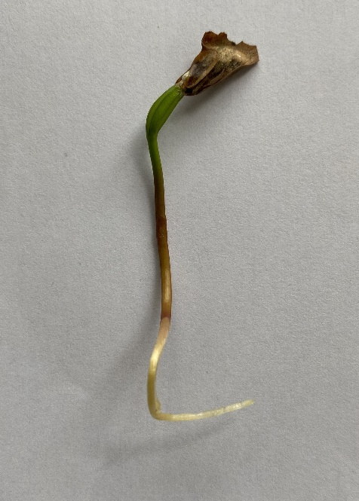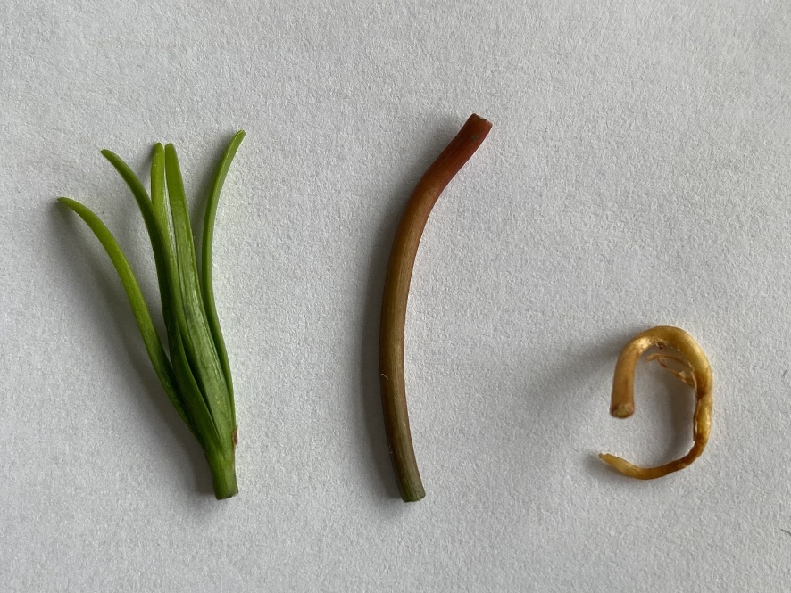
Figure S1. Representative images of seedlings. (a) A seedling on the 10th day following germination; (b) dissected components; leaves, shoot, and root (left to right), separated prior to measurement.

