QUESTION 2
A venturi meter is fitted in a 0.184 m. diameter vertical pipe in order to measure the flowrate of a fluid flowing downwards. The relative density of fluid is 0.8. The throat diameter of venturi meter is 0.092 m. Pressure gauges are fitted to the inlet and to the throat sections. The throat of venturi meter is 0.924 m. below the inlet. If the discharge coefficient of venturi meter is 0.97, find the discharge of the fluid when the pressure drop is 14600 N/m².

Solution

Bernoulli Equation

$$\frac{P1-P2}{ρ}=\frac{{u_{2}}^{2}-{u_{1}}^{2}}{2}-gz$$

$$\frac{14600}{800}=\frac{{u_{2}}^{2}-{u_{1}}^{2}}{2}-9.81*0.924$$

$${u_{2}}^{2}-{u_{1}}^{2}=54.63 {m^{2}}/{s^{2}}$$

Contuinity Equation

u₁*A₁=u₂*A₂

$A1=\frac{π*{d_{1}}^{2}}{4}$; $A2=\frac{π*{d_{2}}^{2}}{4}$

4u₁=u₂

15u₁²=54.63
u₁= 1.91 m/s

Q=Cd*A₁*u₁
Q=0.97*A1*1.91
Q=0.048 m³/s

Q.4. The diagram shows a horizontal nozzle discharging into the atmosphere. The inlet has a bore area of 600 mm² and the exit has a bore area of 200 mm². Calculate the flow rate when the inlet pressure is 400 Pa. Assume there is no energy loss.
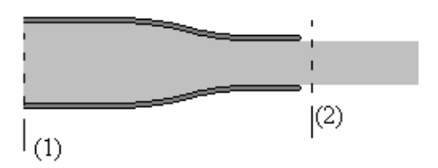

Solution:
