Supporting information to the paper
Bernardi R. E., I. Bekar, M. G. Öztürk3, Ç. Tavşanoğlu. Climate extremes, soils and topography, and past and present land use shape tree cover in Central Anatolia (Türkiye). Applied Vegetation Science.

Appendix S1. Descriptive statistics of explanatory variables.
Variable | Min. | Median | Mean | Max.
Altitude | 388 | 1112 | 1180 | 3693
Slope | 0.001 | 2.97 | 4.68 | 45.58
Aspect | -1.00 | -0.23 | -0.14 | 1.00
Drainage | 4.689 | 8.688 | 9.037 | 26.438
Convexity | -142.40 | -0.43 | 0.05 | 248.45
T | 5.11 | 10.62 | 10.25 | 12.71
Day T Range | 10.32 | 12.54 | 12.59 | 15.18
Isothermality | 31.58 | 36.62 | 36.59 | 40.41
T Seasonality | 708.3 | 786.1 | 783.2 | 834.0
Max. T | 19.47 | 26.49 | 26.28 | 29.69
Min. T | -13.35 | -7.77 | -8.08 | -4.97
T Range | 30.06 | 34.42 | 34.36 | 37.80
T Wettest Q | -2.02 | 7.00 | 5.80 | 12.27
T Driest Q | 13.84 | 19.75 | 19.40 | 21.89
T Warmest Q | 13.87 | 20.03 | 19.67 | 22.45
T Coldest Q | -4.27 | 0.74 | 0.40 | 3.03
P | 342.1 | 418.7 | 430.9 | 674.1
Max. P | 45.00 | 56.76 | 59.65 | 117.34
Min. P | 1.00 | 7.02 | 7.18 | 20.80
P Seasonality | 35.60 | 46.95 | 49.15 | 75.73
P Wettest Q | 124.1 | 152.8 | 161.7 | 309.4
Precipitation of Driest Quarter | 7.00 | 31.72 | 30.0 | 67.08
P Warmest Q | 15.23 | 48.37 | 46.89 | 94.39
P Coldest Q | 99.0 | 137.0 | 149.5 | 318.0
Livestock | 2.82 | 15.00 | 17.99 | 229.6
Ext.livestock | 1.22 | 8.35 | 9.27 | 90.85
SOC | 22.00 | 43.00 | 42.89 | 73.00
CEC | 146.1 | 242.8 | 249.1 | 517.7
pH | 62.00 | 75.20 | 74.90 | 79.13
N | 117.6 | 257.0 | 262.1 | 728.0
Roads | 0.0 | 0.0 | 65.6 | 3090.8
Crops | 0.00 | 0.60 | 0.54 | 1.00
Fire | 0 | 0 | - | 1
Supporting information to the paper
Bernardi R. E., I. Bekar, M. G. Öztürk3, Ç. Tavşanoğlu. Climate extremes, soils and topography, and past and present land use shape tree cover in Central Anatolia (Türkiye). Applied Vegetation Science.

Appendix S2. Histogram of tree cover data. Frequencies of Tree Cover observations. a) Data including zeros, b) zero-excluded data.
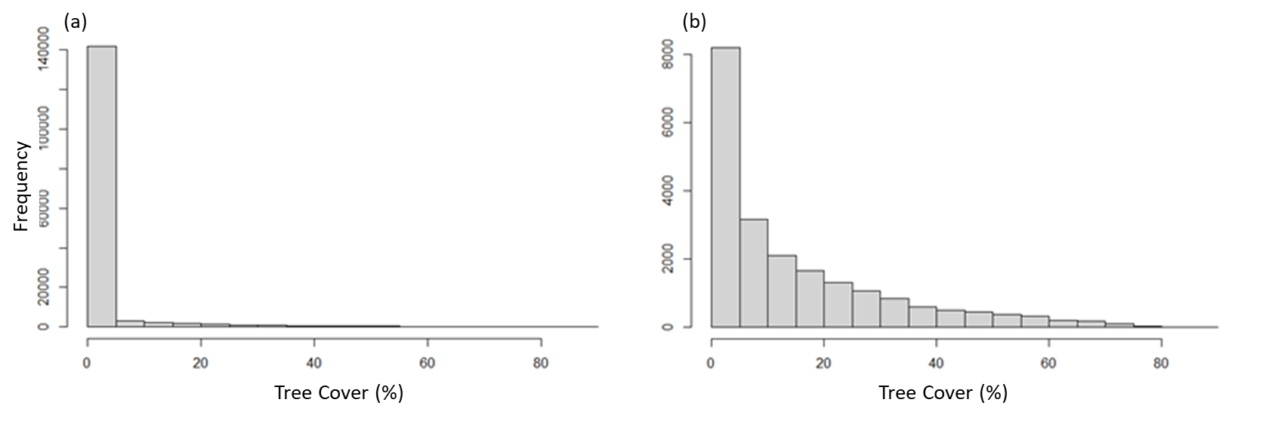

Supporting information to the paper
Bernardi R. E., I. Bekar, M. G. Öztürk3, Ç. Tavşanoğlu. Climate extremes, soils and topography, and past and present land use shape tree cover in Central Anatolia (Türkiye). Applied Vegetation Science.

Appendix S3. Independent analysis of explanatory variables. Summary of the analyses conducted independently to each variable included in the study of tree presence and tree cover. Explanatory power is represented by R² or explained variance.
Variable | Binomial GLM Tree presence |  |  |  | LM Tree Cover
 | Pseudo R² | Estimate | P | Expl. Var. |  | Estimate | P
pH | 0.13 | -0.3790550 | <0.0001 | 0.23 |  | -0.0356440 | <0.0001
N | 0.12 | 0.0164324 | <0.0001 | 0.27 |  | 0.0017010 | <0.0001
T Range | 0.10 | -0.6249110 | <0.0001 | 0.10 |  | -0.0529070 | <0.0001
P | 0.09 | 0.0126564 | <0.0001 | 0.07 |  | 0.0007871 | <00001
Day T Range | 0.09 | -0.9349100 | <0.0001 | 0.07 |  | -0.0768730 | <0.0001
SOC | 0.07 | 0.1070900 | <0.0001 | 0.12 |  | 0.0138520 | <0.0001
Slope | 0.06 | 0.1087500 | <0.0001 | 0.06 |  | 0.0078780 | <0.0001
Min. P | 0.06 | 0.2310760 | <0.0001 | 0.06 |  | 0.0203370 | <0.0001
Max. P | 0.06 | 0.0465554 | <0.0001 | 0.04 |  | 0.0025450 | <0.0001
Crops | 0.06 | -1.688990 | <0.0001 | 0.06 |  | -0.1665180 | <0.0001
P Wettest Q | 0.05 | 0.0162698 | <0.0001 | 0.03 |  | 0.0009670 | <0.0001
T Seasonality | 0.05 | -0.0271029 | <0.0001 | 0.08 |  | -0.0027331 | <0.0001
P Driest Q | 0.05 | 0.0605126 | <0.0001 | 0.04 |  | 0.0054294 | <0.0001
Max. T | 0.04 | -0.3344500 | <0.0001 | 0.05 |  | -0.0355320 | <0.0001
P Warmest Q | 0.04 | 0.0432264 | <0.0001 | 0.03 |  | 0.0035770 | <0.0001
P Coldest Q | 0.04 | 0.0125219 | <0.0001 | 0.04 |  | 0.0008558 | <0.0001
Isothermality | 0.04 | -0.3653490 | <0.0001 | 0.02 |  | -0.0269770 | <0.0001
Roads | 0.03 | 0.0017820 | <0.0001 | 0.01 |  | -0.0000683 | <0.0001
Altitude | 0.02 | 0.0012840 | <0.0001 | 0.04 |  | 0.0001680 | <0.0001
T Wettest Q | 0.02 | -0.0964590 | <0.0001 | 0.05 |  | -0.0127760 | <0.0001
T Warmest Q | 0.02 | -0.2445900 | <0.0001 | 0.02 |  | -0.0265260 | <0.0001
T Driest Q | 0.02 | -0.2636410 | <0.0001 | 0.02 |  | -0.0293400 | <0.0001
Convexity | 0.01 | -0.0193000 | <0.0001 | 0.02 |  | 0.0001285 | 0.043
T | 0.01 | -0.2207650 | <0.0001 | 0.01 |  | -0.0215630 | <0.0001
Drainage | 0.01 | -0.1034430 | <0.0001 | 0.01 |  | -0.0114215 | <0.0001
Aspect | 0.01 | 0.2888640 | <0.0001 | 0.01 |  | 0.0304020 | <0.0001
Min. T | 0.00 | 0.1265000 | <0.0001 | 0.01 |  | 0.0185260 | <0.0001
T Coldest Q | 0.00 | -0.0980290 | <0.0001 | 0.00 |  | 0.0007388 | 0.585
CEC | 0.00 | -0.0027811 | <0.0001 | 0.00 |  | -0.0000652 | 0.296
Ext. Livestock | 0.00 | -0.0199000 | <0.0001 | 0.01 |  | -0.0042129 | <0.0001
P Seasonality | 0.00 | -0.0111092 | <0.0001 | 0.00 |  | -0.0001077 | 0.633
Fire | 0.00 | -1.4982800 | <0.0001 | 0.00 |  | -0.1519550 | 0.0004
Livestock | 0.00 | 0.0017000 | < 0.05 | 0.00 |  | -0.0001401 | 0.392

Supporting information to the paper
Bernardi R. E., I. Bekar, M. G. Öztürk3, Ç. Tavşanoğlu. Climate extremes, soils and topography, and past and present land use shape tree cover in Central Anatolia (Türkiye). Applied Vegetation Science.

Appendix S4. Analysis of correlations. Correlation heatmap of variables used for the analysis of tree presence (a) and cover (b). Blue and red colors denote positive and negative associations; size indicates correlation strength. Highly correlated variables were assessed and excluded from the final models.
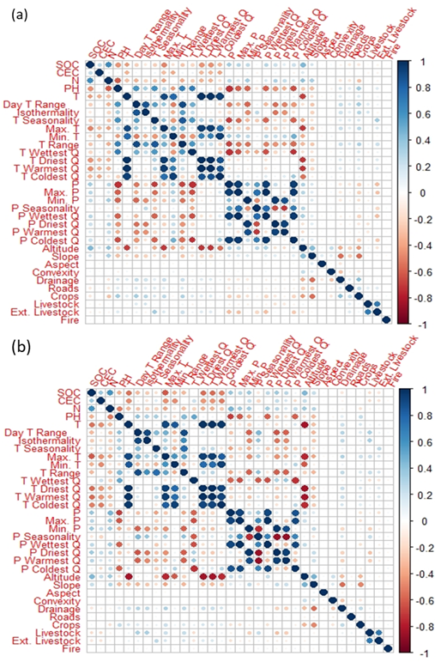

Supporting information to the paper
Bernardi R. E., I. Bekar, M. G. Öztürk3, Ç. Tavşanoğlu. Climate extremes, soils and topography, and past and present land use shape tree cover in Central Anatolia (Türkiye). Applied Vegetation Science.

Appendix S5. Stepwise Selection. Results of the stepwise procedure for selecting the best model for tree presence and (transformed) tree cover data. This table lists the variables included in each model, along with their corresponding Akaike Information Criterion (AIC) values and explained deviance percentages (E.D.). All model results are based on the Generalized Linear Model (GLM).
TREE PRESENCE: Variables included in the model | AIC | E.D.
pH + Roads + N + T Range + Crops + Convexity + Slope + Aspect + SOC + CEC + Drainage + Min. T + Min. P | 88665 | 28.1
pH + Roads + N + T Range + Crops + Convexity + Slope + Aspect + SOC + CEC + Drainage + Min. T | 88764 | 28.0
pH + Roads + N + T Range + Crops + Convexity + Slope + Aspect + SOC + CEC + Drainage | 88953 | 27.9
pH + Roads + N + T Range + Crops + Convexity + Slope + Aspect + SOC + CEC | 89190 | 27.7
pH + Roads + N + T Range + Crops + Convexity + Slope + Aspect + SOC | 89875 | 27.1
pH + Roads + N + T Range + Crops + Convexity + Slope + Aspect | 90412 | 26.7
pH + Roads + N + T Range + Crops + Convexity + Slope | 91009 | 26.2
pH + Roads + N + T Range + Crops + Convexity | 91779 | 25.6
pH + Roads + N + T Range + Crops | 93283 | 24.3
pH + Roads + N + T Range | 95042 | 20.8
pH + Roads + N | 97574 | 20.8
pH + Roads | 102443 | 16.9
pH | 106982 | 13.2
The null model | 123258
TREE COVER: Variables included in the model | AIC | E.D.
N + pH + Aspect + CEC + Isothermality + Crops + Min. T + SOC + Roads + Ext. Livestock + Drainage + Fire | -9994.2 | 33.1
N + pH + Aspect + CEC + Isothermality + Crops + Min. T + SOC + Roads+Ext. + Livestock + Drainage | -9990.3 | 33.0
N + pH +Aspect + CEC + Isothermality + Crops + Min. T + SOC + Roads + Ext. Livestock | -9983.2 | 33.0
N + pH + Aspect + CEC + Isothermality + Crops + Min. T + SOC + Roads | -9967.1 | 32.9
N +pH + Aspect + CEC + Isothermality+Crops + Min. T + SOC | -9814.8 | 32.8
N + pH + Aspect + CEC + Isothermality+Crops + Min.T | -9886.5 | 32.7
N + pH + Aspect + Isothermality + CEC + Crops | -9845.1 | 32.5
N + pH + Aspect + Isothermality + CEC | -9690.1 | 32.0
N + pH + Aspect + Isothermality | -9664.8 | 31.9
N + pH+ Aspect | -9636.0 | 31.8
N + pH | -9433.3 | 31.1
N | -8287.6 | 26.9
The null model | -2110.3
Supporting information to the paper
Bernardi R. E., I. Bekar, M. G. Öztürk3, Ç. Tavşanoğlu. Climate extremes, soils and topography, and past and present land use shape tree cover in Central Anatolia (Türkiye). Applied Vegetation Science.

Appendix S6. Models with a quadratic altitude term. Final models with estimates and p-values of explanatory variables. Left panels: final GLM binomial model for tree presence and LM model for tree cover. Right panels: GLM and LM models, including quadratic altitude term.
GLM Tree presence. R² = 0.28 |  |  |  |  | GLM Tree presence. R² = 0.31
Variable | Estimate | P-value |  |  | Variable |  | Estimate | P-value
Aspect | 0.3280 | <0.0001 |  |  | Altitude |  | 0.00941 | <0.0001
CEC | -0.0070 | <0.0001 |  |  | Altitude² |  | -0.00000378 | <0.0001
Convexity | -0.0166 | <0.0001 |  |  | Aspect |  | 0.3380 | <0.0001
Crops | -1.1800 | <0.0001 |  |  | CEC |  | -0.00681 | <0.0001
Drainage | 0.0793 | <0.0001 |  |  | Convexity |  | -0.0125 | <0.0001
Min._P | 0.0415 | <0.0001 |  |  | Crops |  | -1.2200 | <0.0001
Min._T | 0.1290 | <0.0001 |  |  | Drainage |  | 0.1100 | <0.0001
N | 0.00775 | <0.0001 |  |  | Min._P |  | 0.0355 | <0.0001
pH | -0.1220 | <0.0001 |  |  | N |  | 0.00807 | <0.0001
Roads | 0.00240 | <0.0001 |  |  | pH |  | -0.2080 | <0.0001
Slope | 0.0538 | <0.0001 |  |  | Roads |  | 0.00235 | <0.0001
SOC | 0.0705 | <0.0001 |  |  | Slope |  | 0.0767 | <0.0001
T_Range | -0.1730 | <0.0001 |  |  | SOC |  | 0.0602 | <0.0001
 |  |  |  |  | T_Range |  | -0.2190 | <0.0001
LM Tree cover. R² = 0.33 |  |  |  |  | LM Tree cover. R² = 0.34
Variable | Estimate | P-value |  |  | Variable | Estimate |  | P-value
 |  |  |  |  | Alt2 | -2,23E-07 |  | <0.0001
 |  |  |  |  | Altitude | 0,000537 |  | <0.0001
Aspect | 0.029020 | <0.0001 |  |  | Aspect | 0.028700 |  | <0.0001
CEC | -0.000193 | 0.002 |  |  | CEC | -0.000162 |  | 0.008
Crops | -0.072180 | <0.0001 |  |  | Crops | -0.084680 |  | <0.0001
Drainage | 0.001905 | 0.003 |  |  | Drainage | 0.001517 |  | 0.02
Ext._Livestock | -0.001243 | <0.0001 |  |  | Ext._Livestock | -0.001025 |  | <0.0001
Fire | -0.119000 | 0.006 |  |  | Fire | -0.123300 |  | 0.004
Isothermality | 0.011420 | <0.0001 |  |  | Isothermality | 0.009940 |  | <0.0001
Min._T | 0.010770 | <0.0001 |  |  | Min._T | 0.005148 |  | 0.0007
N | 0.001189 | <0.0001 |  |  | N | 0.001212 |  | <0.0001
PH | -0.015060 | <0.0001 |  |  | PH | -0.0179200 |  | <0.0001
Roads | 0.000046 | <0.0001 |  |  | Roads | 0.000037 |  | <0.0001
SOC | 0.001954 | <0.0001 |  |  | SOC | 0.001638 |  | <0.0001

Supporting information to the paper
Bernardi R. E., I. Bekar, M. G. Öztürk3, Ç. Tavşanoğlu. Climate extremes, soils and topography, and past and present land use shape tree cover in Central Anatolia (Türkiye). Applied Vegetation Science.

Appendix S7. Tree cover vs. explanatory variables retained. The association between tree cover (%) and the independent variables retained by the models. Regression lines for individual variables vs. untransformed tree cover.

